Task 8 : Working and understanding VPN

Objective: Understand the role of VPNs in protecting privacy and secure communication.

Tools:Proton VPN

# VPN Task Steps :

* Choose a Reputable Free VPN Service
* Sign Up for an Account
* Download and Install the VPN Client
* Connect to a VPN Server
* Verify Your IP Address Has Changed

# Screenshots

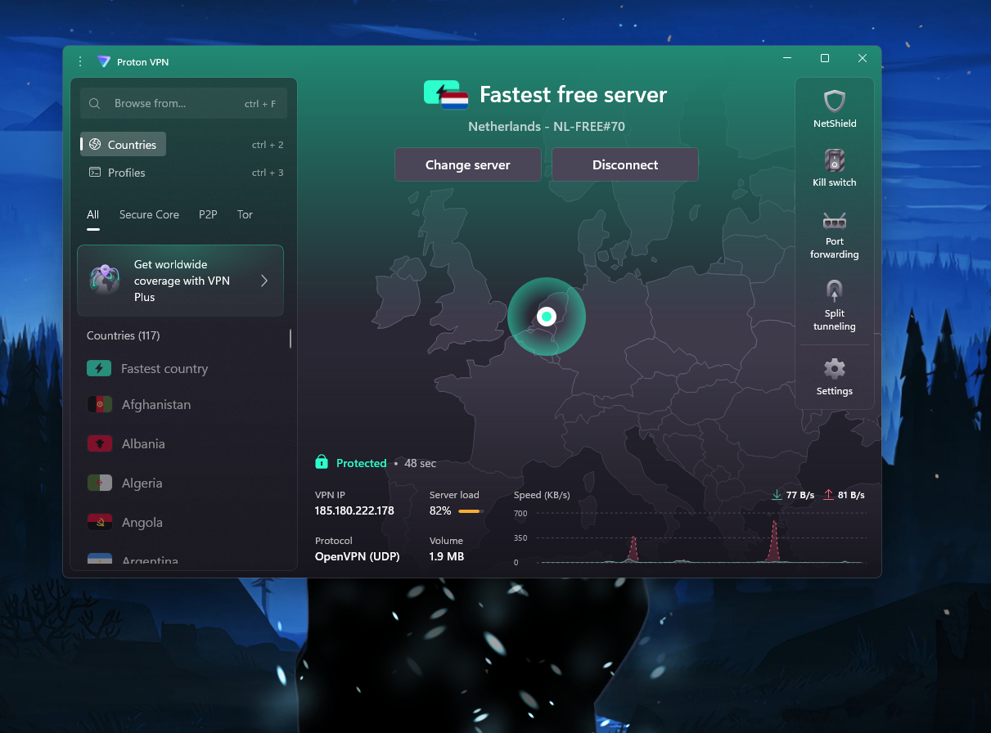

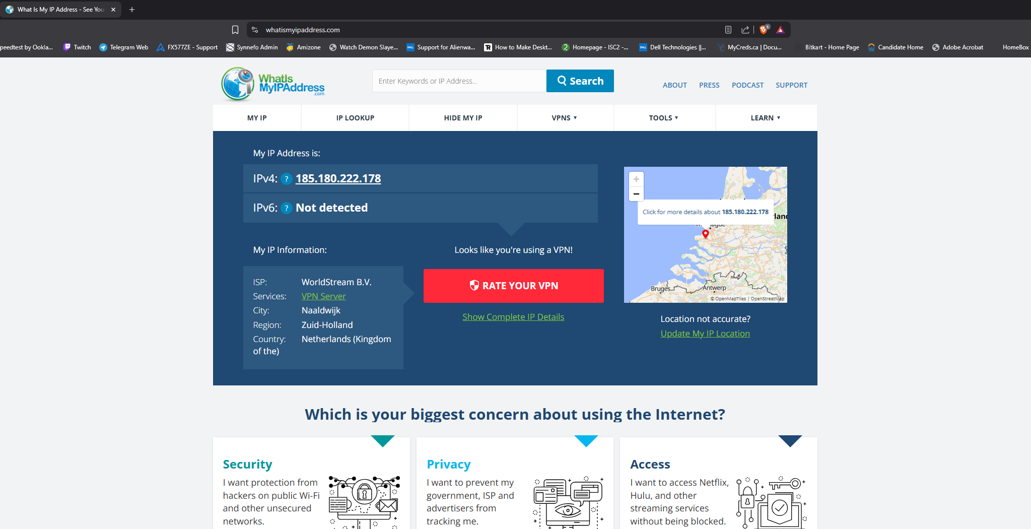

Disconnected VPN

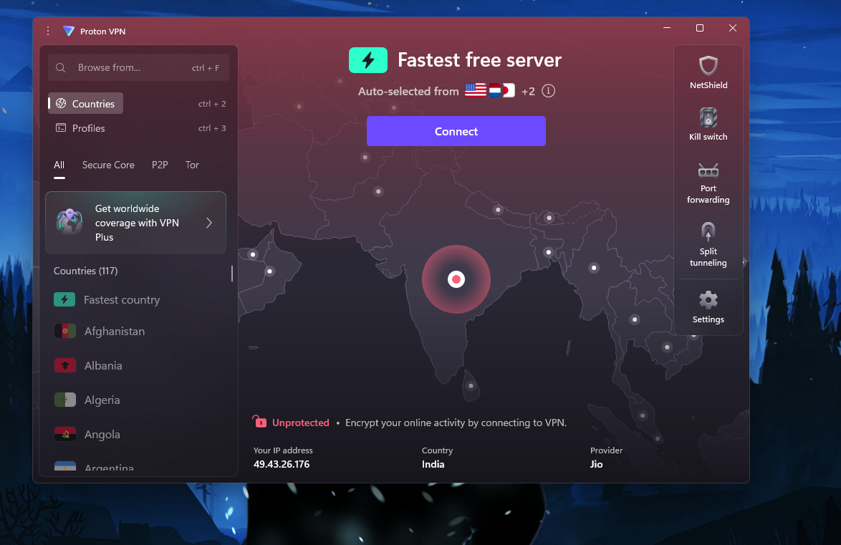

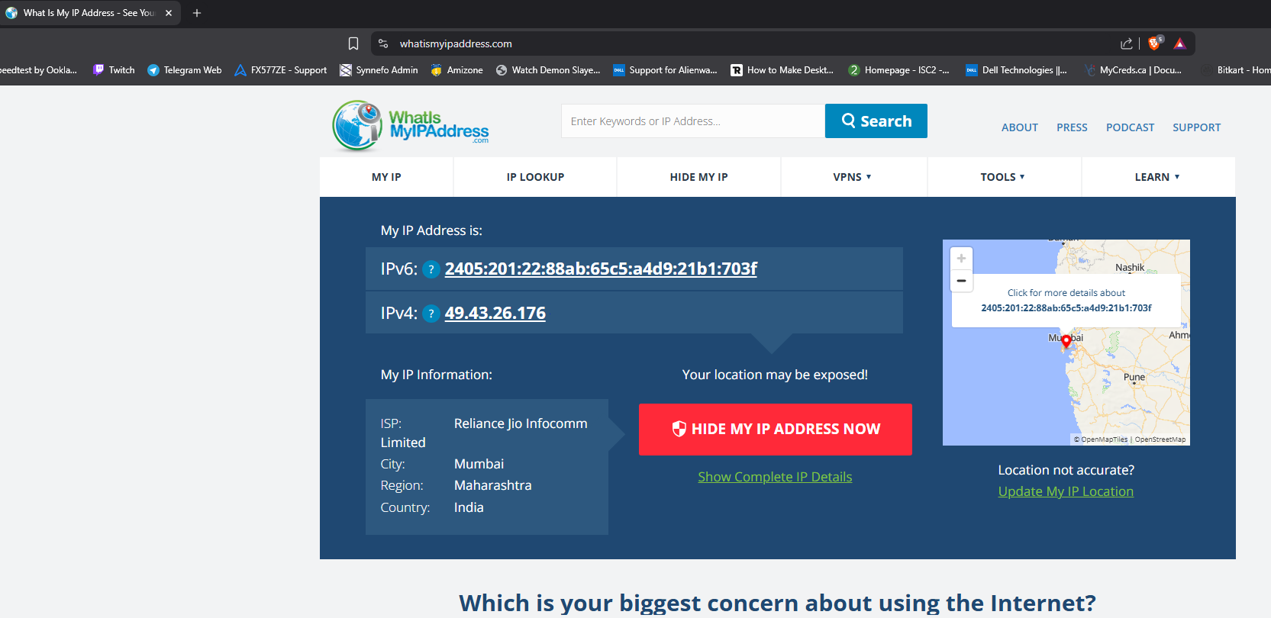

# Summary: VPN Benefits & Limitations

## Benefits of Using a VPN:

* Privacy Protection: Hides your IP address and online activity from ISPs, trackers, and hackers.
* Data Encryption: Secures your internet traffic using strong encryption (e.g., AES-256).
* Access to Restricted Content: Allows access to geo-blocked websites, apps, and streaming services.
* Safe Public Wi-Fi Use: Protects your data when connected to public or unsecured networks.
* Anonymity: Helps maintain anonymity by masking your digital footprint.

## Limitations of a VPN:

* Reduced Speed: May slow down your internet connection due to encryption and server routing.
* Limited Features in Free Plans: Free VPNs often have data caps, fewer servers, and slower speeds.
* Not 100% Anonymous: VPNs can't protect against all threats (e.g., malware or phishing).
* Trust Issues: Some VPNs log data or are based in countries with strict data laws.
* Blocked by Some Services: Certain websites or streaming platforms block VPN traffic.